**Experiment-1 Study of Networking Commands**

ECP316 (Communication Networks)

Polastee Bhoi (BT23EEE042)

**Aim:** To Study Networking Commands on Command Prompt.

**Tools Used:** Command Prompt

**Theory:**

**Command Prompt:** The Command Prompt (cmd) is a command-line tool in Windows that lets users run commands for various tasks such as managing files, navigating the system, and troubleshooting issues. It allows for direct interaction with the operating system, facilitating advanced configurations and automation through batch scripts, which improves user control and efficiency.

We’ll be checking the following commands on command prompt:

1. **ping:** The ping command is used to check the network connection between devices. It sends ICMP (Internet Control Message Protocol) echo requests to a specified host and waits for a reply. This tool is useful for diagnosing network problems by measuring the time it takes for messages to travel from the source to the destination and back.
2. **ipconfig:** This command is used to display and manage the IP configuration of a Windows device. It provides details about the IP address, subnet mask, default gateway, and other network information. It's helpful for troubleshooting network issues and renewing DHCP-assigned IP addresses.
3. **ipconfig/?:** This command displays a list of command-line options and descriptions for the ipconfig utility. It's essentially a help command that provides guidance on how to use the different parameters and switches available with ipconfig, such as releasing or renewing IP addresses, flushing DNS, and more.
4. **ipconfig/all:** The ipconfig/all command displays detailed information about the network configuration of a Windows device. It includes the IP address, subnet mask, default gateway, DNS servers, MAC address, and other network-related details for all network adapters on the system. It's particularly useful for in-depth network troubleshooting and diagnostics.
5. **getmac:** It displays the Media Access Control (MAC) addresses of the network interfaces on a Windows device. It also shows the network transport names associated with these interfaces. This command is useful for identifying network adapters and troubleshooting network issues.
6. **tracert:** The tracert command, short for "trace route," traces the path data packets take from your device to a destination host. It displays each hop (router) the packet passes through and the round-trip time for each hop. It's handy for diagnosing network routing issues and identifying where data transmission delays occur.
7. **netstat:** The netstat command provides network statistics, connections, and port activity on a device. It displays active TCP connections, listening ports, Ethernet statistics, IP routing table, and more. This command is essential for monitoring and troubleshooting network performance and security.

**Procedure:**

1. Open the command prompt of your computer using “Win+R” type “cmd” and enter.
2. Use the commands and observe which type of output it is giving.
3. For ipconfig/? And related commands use command prompt as administrator.

**Observations:**

**ping**

**ipconfig**

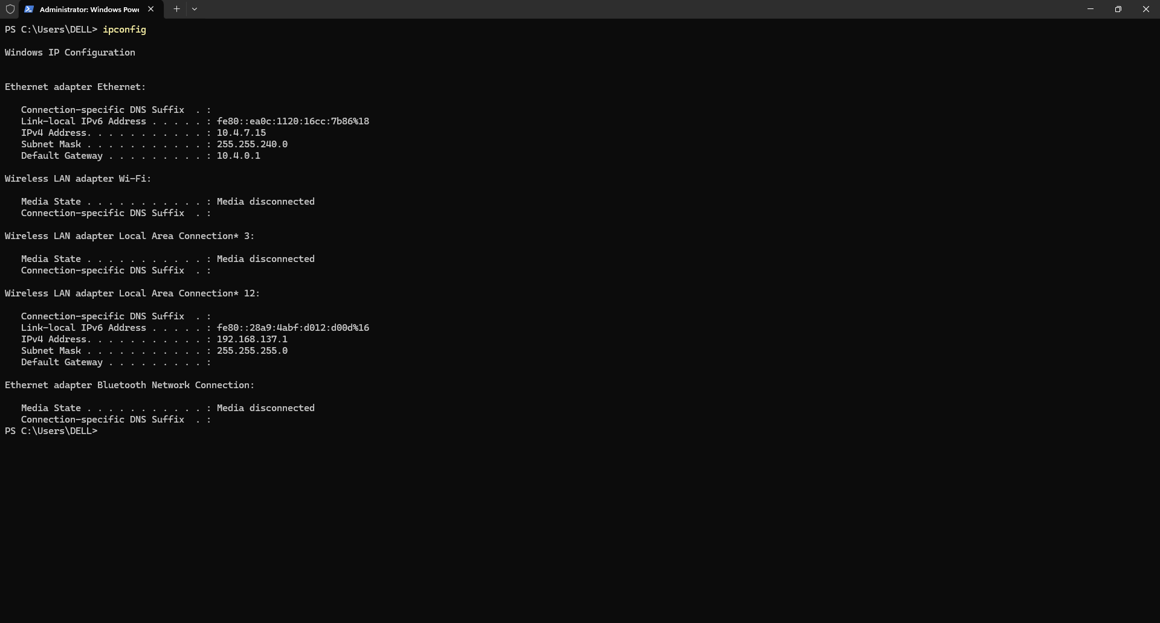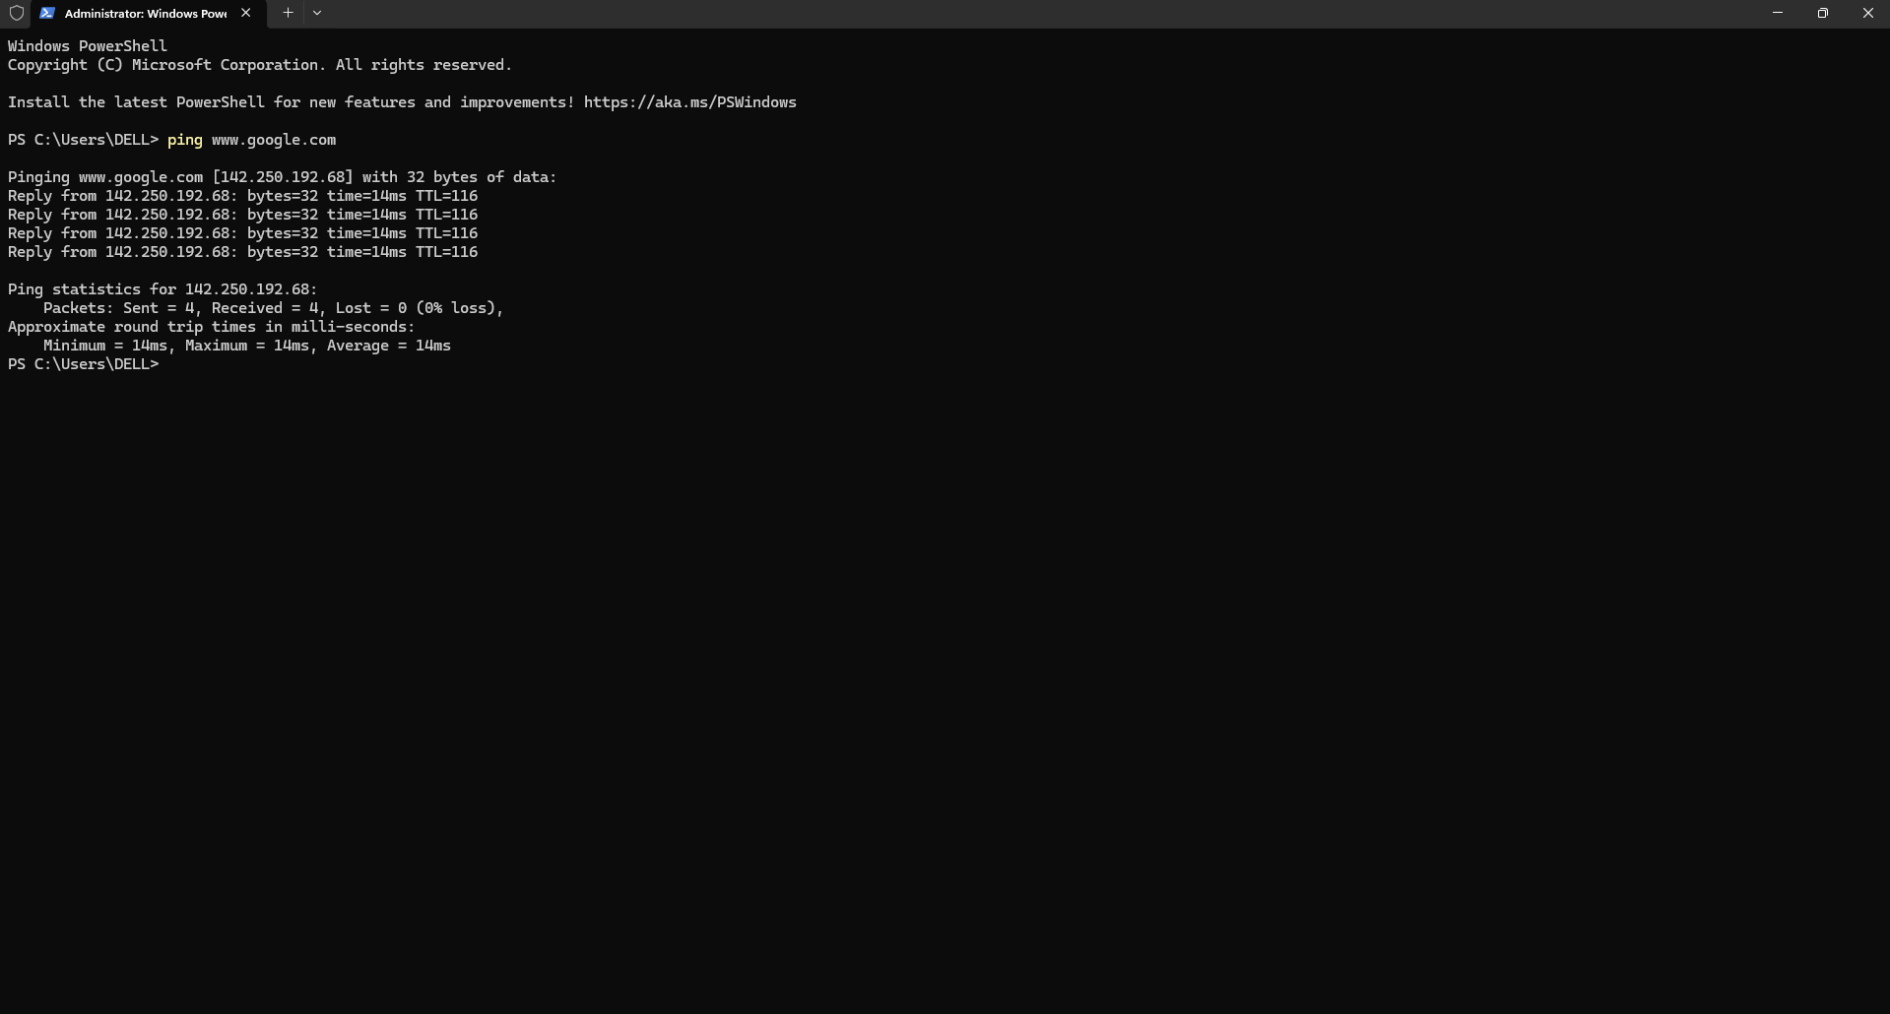

**ipconfig/? (on administrator only)** 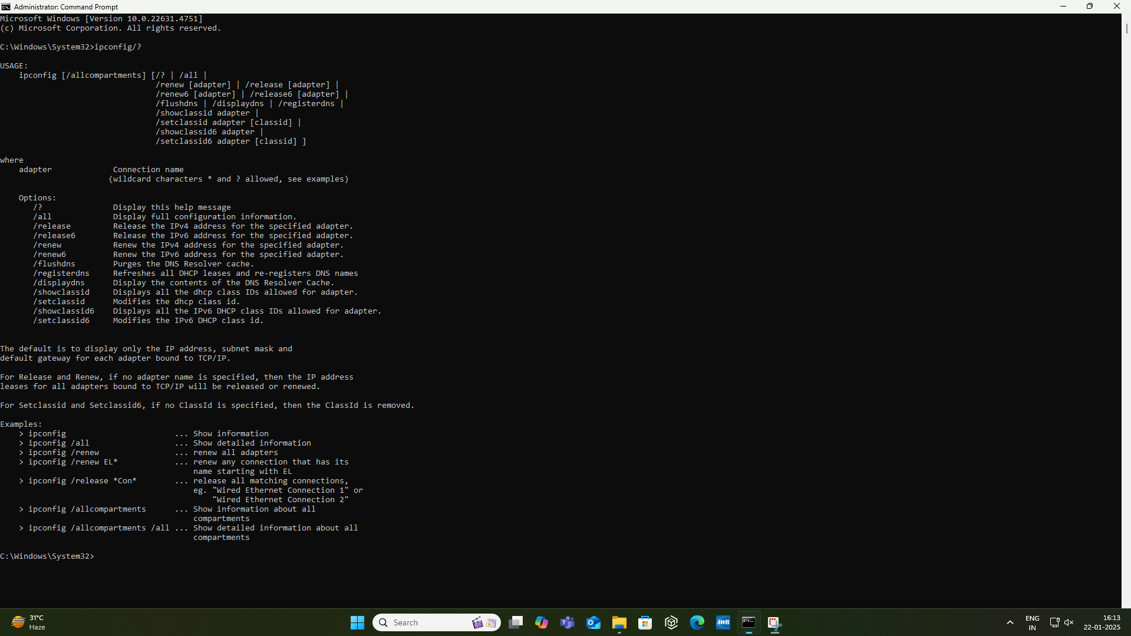

**ipconfig/all (on administrator only)**

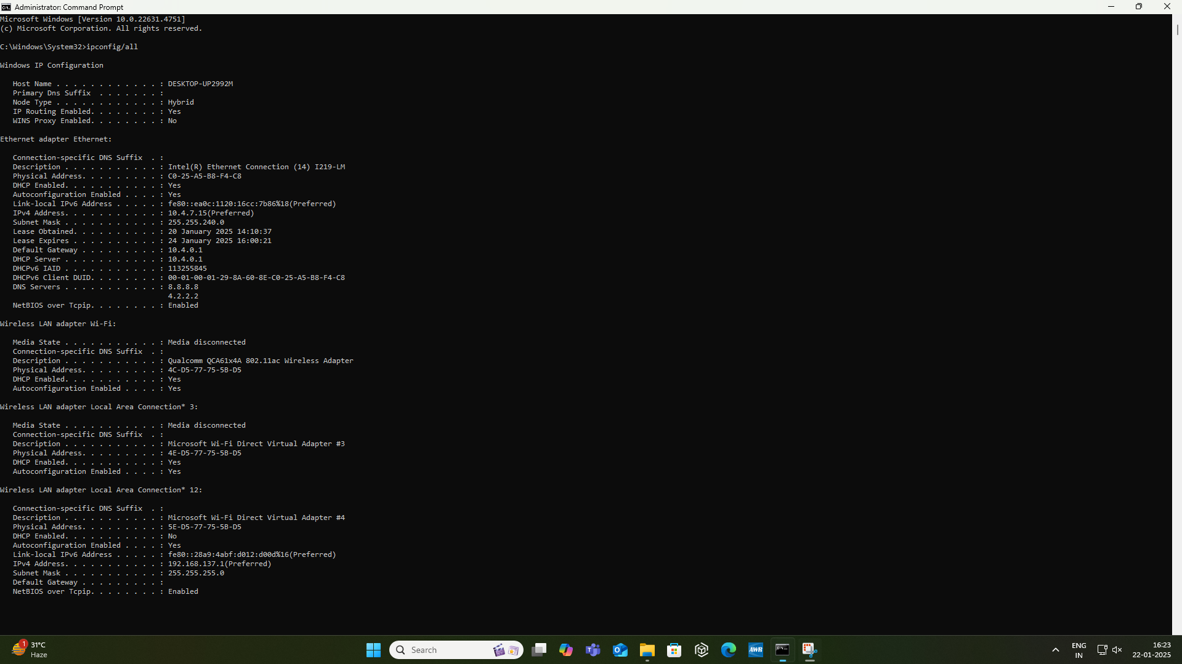

**getmac**

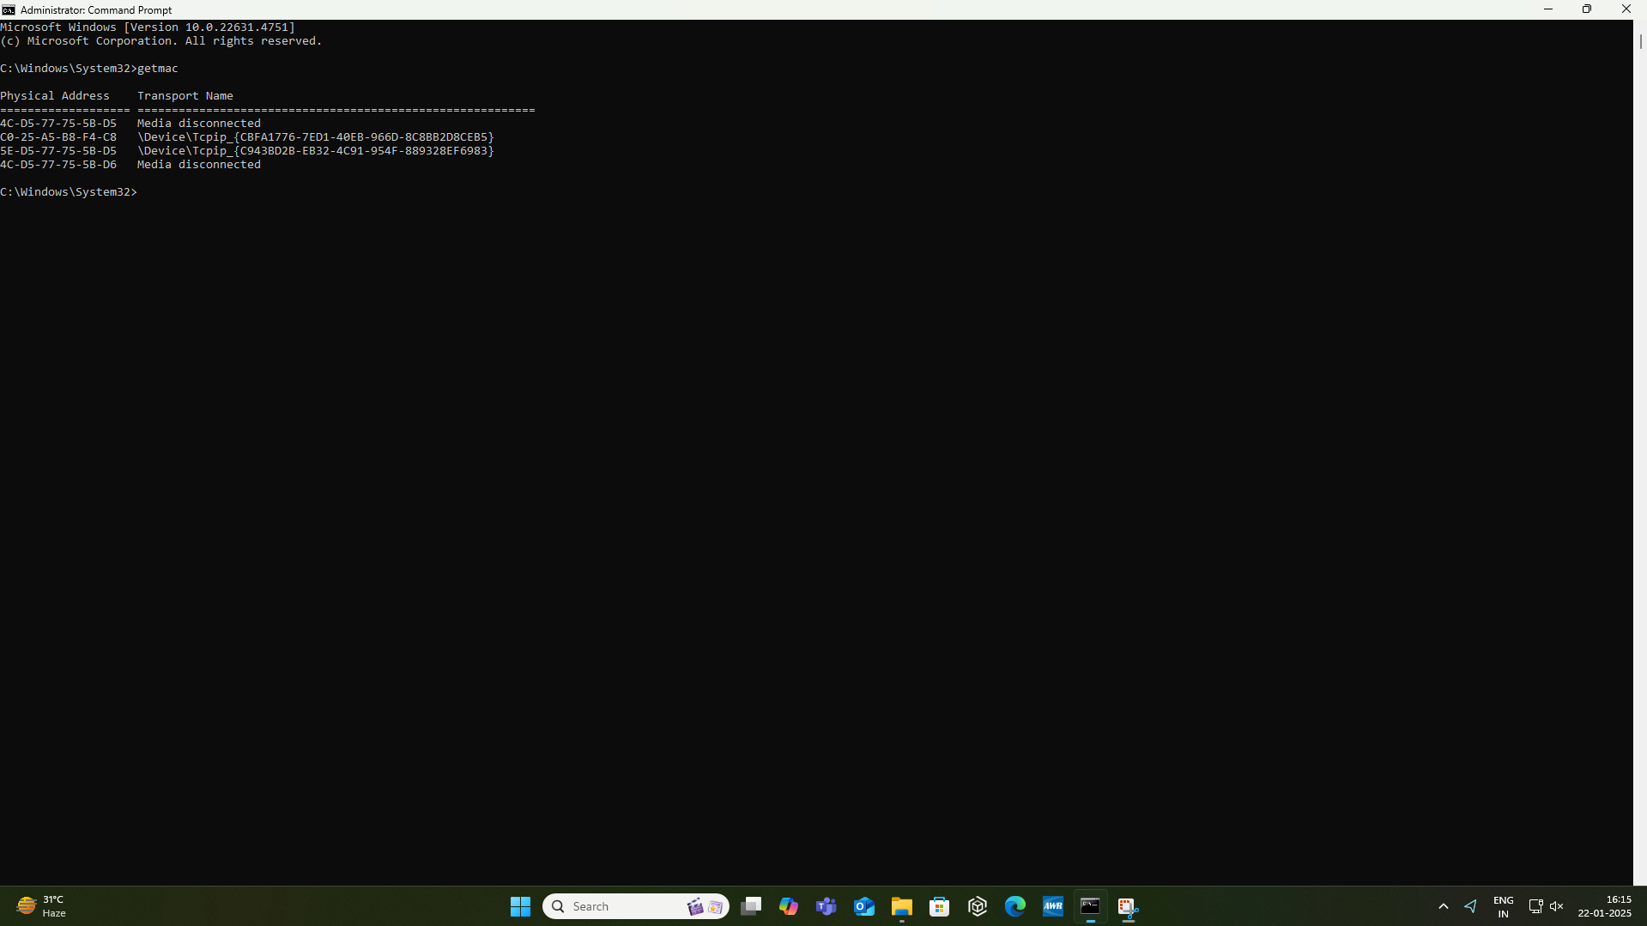

**tracert**

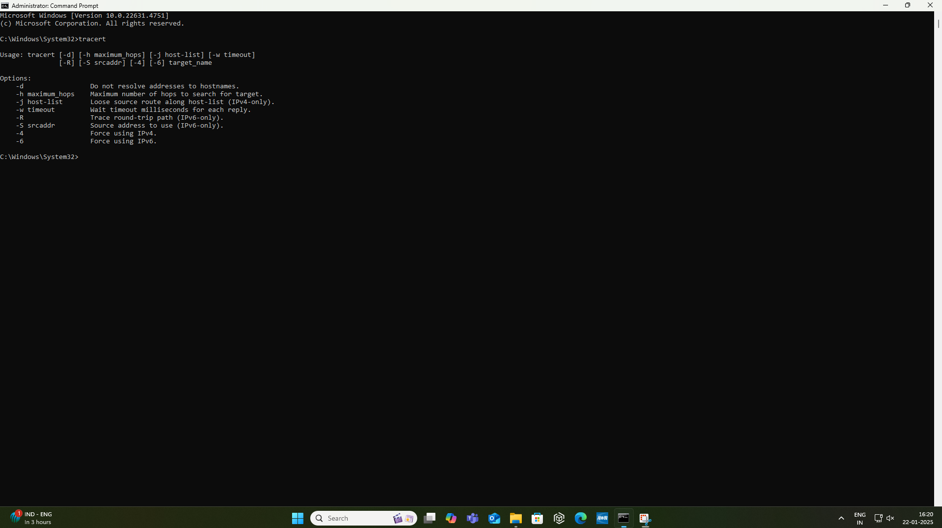

**tracert** [**www.google.com**](http://www.google.com)

**tracert** [**www.instagram.com**](http://www.instagram.com)

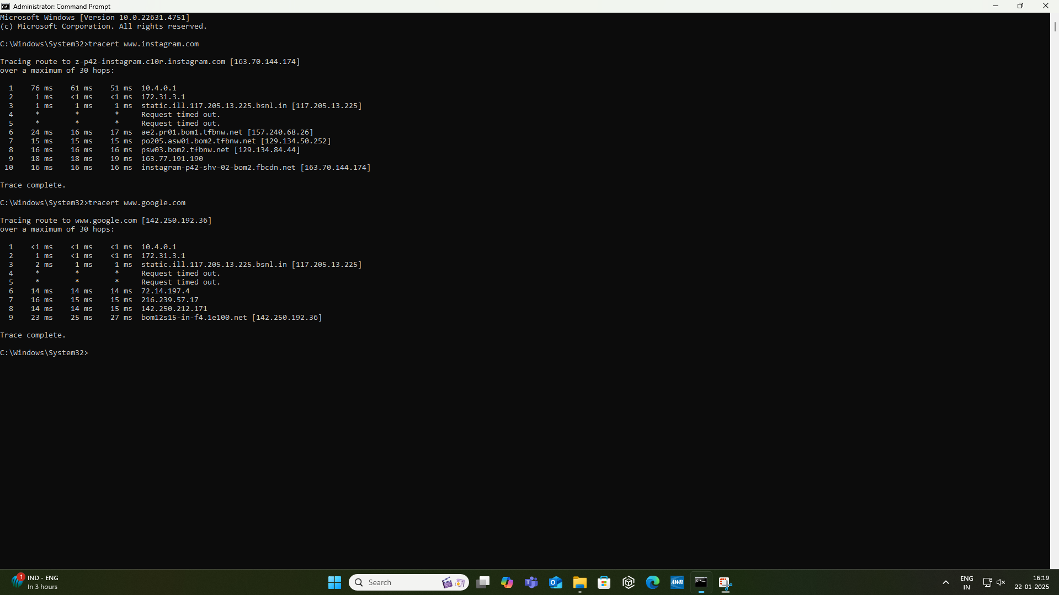

**netstat:**

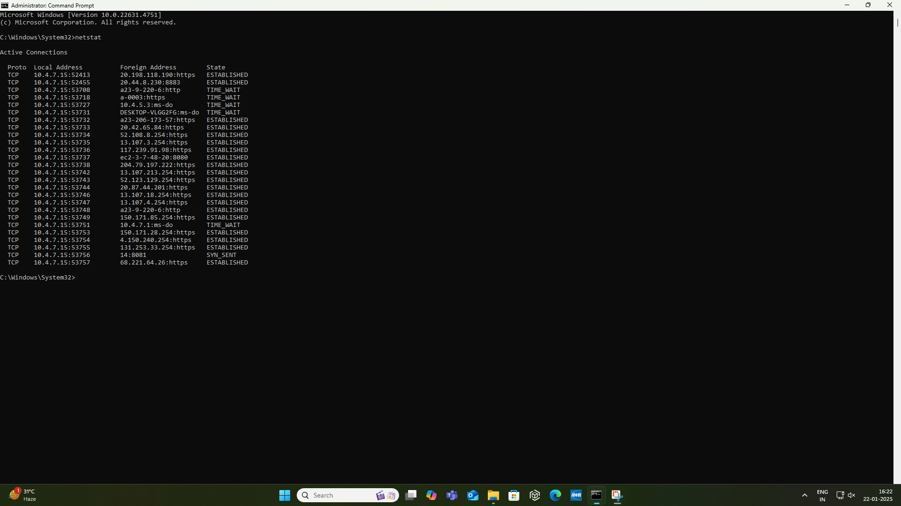

**Result and Conclusions:**

* In this experiment, we have explored and observed essential basic networking commands.
* Each command serves a unique purpose in diagnosing, monitoring, and managing network connectivity and performance.
* By understanding these commands, we gain valuable insights into network operations and troubleshooting techniques, which are crucial for maintaining efficient and secure network environments.